Experiment 6: Forward Chaining

Aim
To implement forward chaining to infer new facts.

Procedure
1. Start with known facts.
2. Apply rules to infer new facts iteratively.
3. Stop when no more facts can be inferred or the goal is achieved.

Code
facts = {'A'}
rules = {
'A': ['B'],
'B': ['C']
}
inferred = set(facts)
while True:
added = False
for key, values in rules.items():
if key in inferred:
for value in values:
if value not in inferred:
inferred.add(value)
added = True
if not added:
break
print("Inferred facts:", inferred)

Output
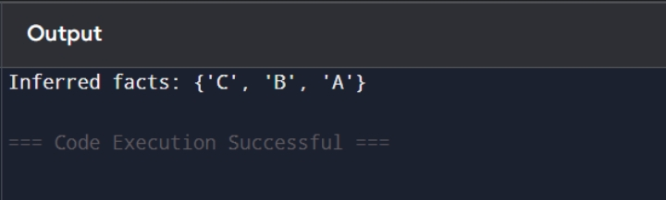

RESULT
Forward Chaining is implemented.

